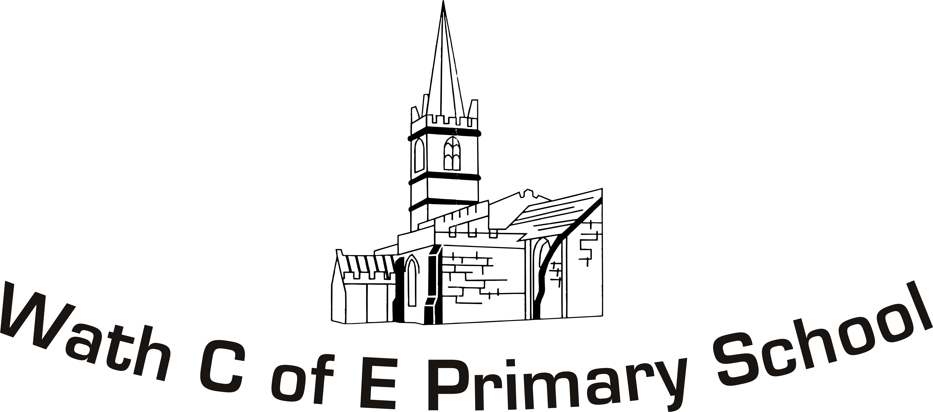


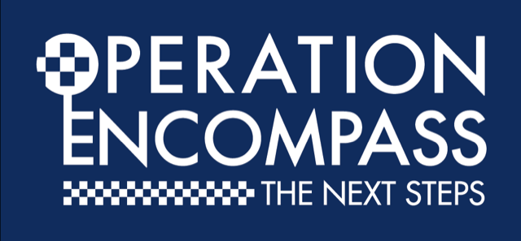

Dear Parent/Carer,

I would like to inform you of a project that is being introduced in South Yorkshire. It is called Operation Encompass, a partnership between South Yorkshire Police and Education, supported by each Local Safeguarding Children’s Partnership.

Operation Encompass has been designed to provide support for any child in school who may be affected by a domestic abuse incident where the police have attended.

A key safeguarding member of staff in school will be informed when a domestic abuse incident has been recorded within the previous 24 hours or over the weekend. This will enable school to monitor children possibly affected and, where required, support if necessary. This will remain confidential; no information about specific incidents is shared with school. The school will, however, be able to make provision for possible difficulties experienced by children who have been involved in, affected by, or witnessed a domestic abuse incident.

We are keen to offer the best support possible for our children and young people and we believe Operation Encompass will enhance the safeguarding within school. This will be extremely beneficial for all those involved.

Our Key Adults are Deborah Whelan/Paul Beevor.

Deborah Whelan
Designated Safeguarding Lead

